Rattus norvegicus

Luka insisi

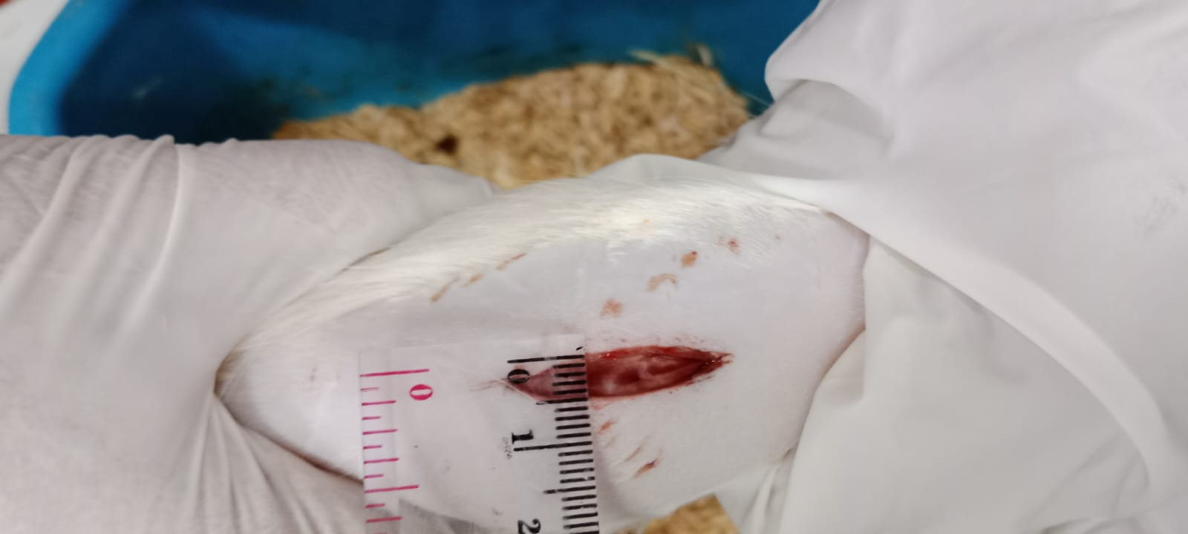

Hari pertama

|  |  |
| --- | --- |
| Nacl | Betadine |

|  |  |
| --- | --- |
| Gel 10% | Gel 20% |

|  |
| --- |
| Gel 30% |

Hari kedua

|  |  |
| --- | --- |
| Nacl | Betadine |

|  |  |
| --- | --- |
| Gel 10% | Gel 20% |

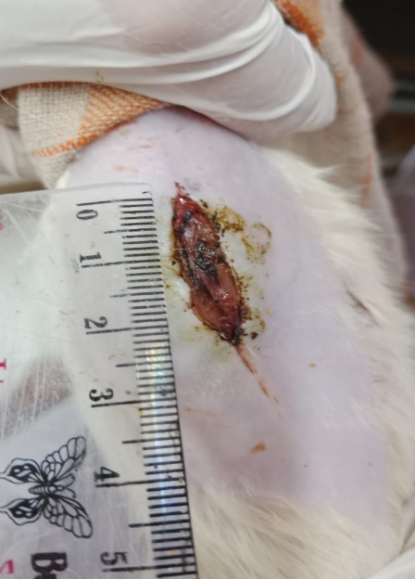

Gel 30%

Hari ketiga

|  |  |
| --- | --- |
| Nacl | Betadine |

|  |  |
| --- | --- |
| Gel 10% | Gel 20% |

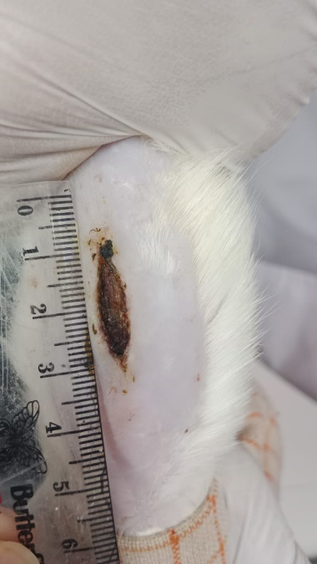

Gel 30%